

GUIDELINES FOR LOT RELEASE OF VACCINES AND OTHER BIOLOGICAL PRODUCTS

DECEMBER, 2025

FOREWORD

WHO considers the lot release of vaccines and other biological products by regulatory authorities as part of the regulation of vaccines and recommends that the National Regulatory Authority (NRA) or National Control Laboratory (NCL) in each country conduct an independent assessment of each lot of a licensed vaccine before it is released on the market.

Rwanda FDA performs the lot release of vaccines and concerned biological products and considers the provisions of technical regulations No. LSD/VBT/TRG/001 version 2 to issue the guidelines No. LSD/VBT/GDL/001 version 2 for lot release of vaccines and concerned biological products.
This document is intended to provide guidelines to the manufacturers and suppliers of vaccines and biological products on the lot release process in Rwanda.

Rwanda FDA appreciates the efforts of key partners and stakeholders who contributed to the development and validation of these guidelines.

Prof. Emile BIENVENU
Director General

DOCUMENT DEVELOPMENT HISTORY

First issue date | 14/10/2022
Effective date of this revision | Refer to the approval date

DOCUMENT REVISION HISTORY
Date of revision | Version number | Changes made and/or reasons for revision
- | 1 | First issue
23/07/2025 | 2 | - A template updated in accordance with the Guidelines Nº 001/RLRC/2022 of 18/10/2022 on Legislative Drafting.  - The scope was expanded to include animal vaccines and other biological products, both imported and locally manufactured  - A new table on the information to be included in the lot summary protocol was introduced in this new version.  - This guideline version 2 gives and details a new way of submitting an application for lot release. It also highlights the assessment of the application (see § 4.1)  - In the guideline, version 1, the number of samples to be submitted was stated while in this version 2 states that the number of samples should be product-specific. It was added that, in case of blood derivatives, plasma and pool samples are submitted prior to the final product sample or together.  - The sampling procedure (in version 1) was removed in this version 2 of the guidelines.  - Criteria for risk-based evaluation of specific products in lot release were included in this new guideline  - The lot release time frame was also included  - The endorsement of the guidelines was edited to include the VBT and QMS Division Managers respectively.  - The lot release application form was edited and moved from appendices to Annexes in this version 2.  - The lot release certificate was edited and moved from appendices to Annexes.  - Various appendixes were included in this version 2 including the risk assessment tool, the standard lot release process flow chart, the process flow of decision making, the process for non-compliant flow, the expedited lot release process, a list of competent regulatory authorities, requirements for each to release application.

TABLE OF CONTENTS
FOREWORD 1
DOCUMENT DEVELOPMENT HISTORY 2
DOCUMENT REVISION HISTORY 2
TABLE OF CONTENTS 4
ACRONYMS AND ABBREVIATIONS 6
GLOSSARY / DEFINITIONS 7
chapiter I. INTRODUCTION 9
SCOPE 9
CHAPTER II. PROCEDURES FOR LOT RELEASE 10
II.2 Lot release pathways 10
II.2.1.1. Standard Lot Release Pathway 11
II.3.3.3. Reliance/Recognition Lot Release pathway 16
II.4. Data monitoring 16
II.5. Evaluation of the lot and the decision-making process 16
II.6. lot release or lot rejection certificate 16
II.7. Lot release timeline 16
II.8. Communication 17
chapter III.REQUIREMENTS FOR LOT RELEASE SUBMISSION 17
III.1. Application submission 17
III.1.2. Samples 18
III.1.3. Proof of payment 18
CHAPTER IV. REFERENCES 18
APPENDIXES 20
ENDORSEMENT OF THE GUIDELINES 33

ACRONYMS AND ABBREVIATIONS

Rwanda FDA | Rwanda Food and Drugs Authority
GMP | Good Manufacturing Practices
LSD | Laboratory Services Department
MAH | Marketing Authorization Holder
NRA | National Regulatory Authority
NCL | National Control Laboratory
MAH | Marketing Authorization Holder
EDQM | European Directorate for the Quality of Medicines
OCABR | Official Control Authority Batch Release
WHO | World Health Organization
CoA | Certificate of Analysis
LSP | Lot Summary Protocol
PDMP | Plasma-Derived Medicinal Product
QA | Quality Assurance
QC | Quality Control
EUL | Emergency Use Listing
UN | United Nations

GLOSSARY / DEFINITIONS

Annual product quality review: a report submitted annually by manufacturers to the NRA/NCL, containing production information on both bulk and final lots, including test methods and results and reasons for any recalls and corrective action taken, as well as other pertinent post-marketing information.
Biological products: also referred to as biologicals, are medicines whose active substance is made by or derived from a living organism, such as a microorganism (bacteria, yeast), plant cell, animal cell, or plasma. Biological products are diverse and include products such as vaccines, growth factors, immune modulators, monoclonal antibodies, and products derived from human blood and plasma (PDMPs).
Certificate of Analysis (CoA): a report document that contains all release test results and their specification acceptance criteria, based on the product marketing authorization file, which has been evaluated and approved by the responsible NRA during product registration.
Diluent: a liquid used to mix with a lyophilised (freeze-dried) vaccine to reconstitute the lyophilised vaccine and provide the final vaccine for administration.
Lot: a defined quantity of starting material, packaging material, or product processed in a single/ series of processes so that it is expected to be homogeneous. It may sometimes be necessary to divide a lot into several sub-lots, which are later accumulated to form a final homogeneous lot. In continuous manufacture, the lot must correspond to a defined fraction of the production, characterized by its intended homogeneity. The lot size can be defined either as a fixed quantity or as the amount produced in a fixed time interval.
Lot Release (LR): the process of NRA/NCL evaluation of an individual lot of licensed vaccines and/or other biological products before approving its release into the market.
Lot Release Certificate: an official document that authorizes the manufacturer to release the specific lot into the market.
Lot Summary Protocol (LSP): a document summarizing all manufacturing steps and test results for a lot of biological products, which is certified and signed by the responsible person of the manufacturing company. Test results include the test specifications and the date of test conducted.
﻿Marketing Authorization: an official document/certificate issued by Rwanda FDA for the purpose of marketing or free distribution of a product after evaluation for safety, efficacy and quality.
Marketing Authorization Holder (MAH): a person or legal entity granted a marketing Authorization/ registration certificate and who is responsible for all aspects of the product, including quality, safety, and compliance with conditions of registration.
Non-Compliance: failure or refusal to comply with a standard or a set of limits.
Plasma Derived Medicinal Products (PDMPs): also termed plasma derivatives, plasma products, or fractionated plasma products, are a range of biological products obtained by the fractionation process of human plasma. Examples of these products include albumin, blood coagulation factors, protease inhibitors, anticoagulants, and immunoglobulins.
Responsible NRA/NCL: The NRA/NCL is taking responsibility for regulatory oversight of a product with regard to the critical regulatory functions defined by WHO, including independent lot release. The responsible NRA/NCL is usually that of the country of manufacture unless specific agreements exist within defined territories, such as in the European Union, where the “country” of manufacture is the European Union and the activity of the responsible NRA/NCL is designated among member states.
Risk-Based Approach: NRA reliance approach that considers factors, such as the type and source of products evaluated, the level of resources and expertise available in the NRA, the public health needs and priorities of the country, and opportunities for reliance.
﻿Self-procured biological product: a biological product that is procured directly from a source outside the country without the intervention of WHO/United Nations procurement programmes.
Specifications: A list of tests, references to analytical procedures, and appropriate acceptance criteria, which are numerical limits, ranges, or other criteria for the tests described in the marketing authorization dossier. They establish a set of criteria to which an active substance, a bulk, or a finished product should conform to be considered acceptable for its intended use. Specifications are critical quality standards proposed and justified by the manufacturer and approved by the regulatory authorities.
Vaccine: A biological preparation intended to induce or boost a specific and active immunity in humans against a particular disease. In addition to the antigen, it may contain multiple components (excipients), and each component may have unique safety implications.

chapter I. INTRODUCTION

The “Guidelines for Lot Release of Vaccines and other Biological Products” are intended to serve as a guide for requirements and procedures for lot release of biological products. They are issued within the framework of the Rwanda FDA Regulations Governing the Lot Release of Vaccines and other Biological Products LSD/VBT/TRG/001 Version 2.
Biological products form a diverse group of medicines which includes vaccines, growth factors, immune modulators, monoclonal antibodies, as well as plasma-derived medicinal products (PDMPs). Unlike chemically synthesized drugs, biological products are manufactured from biological sources.
Vaccines are used mainly in the prophylaxis and are largely used in a healthy population. Problems regarding vaccine quality have a direct impact on the public acceptance of immunization programs, thus potentially compromising public health strategies. Consequently, it is essential to ensure the consistent quality of each lot before it is released onto the market.
Plasma-derived medicinal products (PDMPs) are prepared from human plasma and include products such as albumin, coagulation factors and immunoglobulins, which are lifesaving for several chronic and acute life-threatening diseases. They are complex in nature, and their quality and safety rely heavily on source materials as well as subsequent manufacturing processes, including infectious marker testing and viral removal and inactivation.
﻿Furthermore, biological products and many of the tests applied to them have an inherent potential variability. Therefore, an independent review of critical data from each lot is essential to ensure the consistent quality of each manufactured lot.
The lot release of biological products is a part of the regulation of biological products and involves the independent assessment of each lot of a licensed biological product before it is released for use. The World Health Organization (WHO) provides recommendations and strategies for the lot release of biological products by the National Regulatory Authorities (NRAs) or National Control Laboratories (NCLs) of producing and procuring countries. According to the WHO Guidelines for independent lot release of vaccines by regulatory authorities, current approaches to conducting lot release include review of the lot summary protocol only, review of the lot summary protocol with independent testing, and recognition/acceptance of lot release certificates from the responsible NRA/NCL. These approaches are not mutually exclusive and may be product-specific.

SCOPE

These guidelines apply to vaccines and Plasma-Derived Medicinal Products (PDMPs) or animal-derived anti-sera, anti-venoms, anti-rabies, etc., whether locally manufactured or imported, registered for human and animal use. The document is intended to guide local manufacturers, MAHs, and suppliers of human and animal vaccines and PDMPs regulated by the Rwanda FDA lot release process. It may also be relevant to public health entities, such as a national immunization programme.
CHAPTER II. PROCEDURES FOR LOT RELEASE
These guidelines are largely based on the recommendations outlined in WHO’s guidelines for independent lot release of vaccines by regulatory authorities.
Rwanda FDA is responsible for deciding on an appropriate strategy for each vaccine lot release, taking into consideration the nature of the vaccine, the post-marketing experience (including production history and safety profile), and the availability of other independent evidence of product quality.
It is also the responsibility of the manufacturers, MAHs, or suppliers to follow the procedures described in these guidelines while submitting the request for lot release of already registered biological products.
II.1. General considerations
﻿Rwanda FDA takes responsibility for the regulatory oversight of the quality of biological products manufactured and/or authorized in Rwanda, either for domestic use or for export. Its laboratory initially tests the vaccines or any concerned biological products, in addition to carrying out a critical review of the summary protocols.
After confirmation of the consistency of the quality through testing the chosen parameters, the release of further lots involves the testing of all product-specific predetermined attributes or selected testing or no testing, depending on the nature of the product and established experience.
﻿Rwanda FDA laboratory considers reviewing the lot summary protocol as a minimum for self-procured biological products. Independent tests may be considered as well, depending on the production records and the nature of the product. Recognition/ acceptance of lot release certificates from the NRA/NCL of the country where the biological product is manufactured, or from another competent NRA/NCL, will also be considered as an alternative.
For biological products supplied through United Nations agencies, further release by Rwanda FDA may not be required because such products are prequalified by WHO and released by the responsible NRA/NCL.
II.2. Lot release pathways
The lot release of vaccines and other concerned biological products in Rwanda is conducted based on the determined product-specific risk through one of the following pathways:
II.2.1. Standard release pathway: in which vaccines and other concerned biological products are categorized into three risk groups: Low, moderate, and high-risk groups. The product-specific risk is determined by a risk assessment tool (Appendix I).
II.2.2. Expedited release pathway: is applied for any biological product under certain exceptional cases.
II.2.3. Recognition/Reliance pathway: is applied to vaccines and other concerned biological products pre-qualified (PQ) by WHO (https://extranet.who.int/pqweb/vaccines/prequalified-vaccines), and released by the responsible stringent NRA/NCL of the country of origin, NRAs/NCLs with ML3/ML4 (vaccines), Functional NRA (vaccines), or NRAs/NCLs with a formal agreement with Rwanda FDA.

II.2.1.1. Standard Lot Release Pathway
Lot release through standard release pathways consists of:
- Review of lot summary protocol,
- Independent testing of samples submitted by the manufacturer based on a risk-based approach. The risk associated with a specific product is defined following Appendix I.
The process for the standard lot release pathway is depicted in Appendix II. In case the lot does not comply with the specifications of any test indicated in the marketing authorization file, a process described in Appendix III shall be followed.

Review of lot summary protocol
The lot summary protocol (LSP) summarizes information taken from the production and testing records according to GMP requirements, to ensure that the lot meets the specifications as provided in the product marketing authorization dossier. In addition, the lot summary protocol and CoAs submitted to the Rwanda FDA have to be approved by a designated person responsible for QA or QC certifying that the lot was manufactured according to the cGMP requirements. Moreover, the Rwanda FDA has to be informed of any marketing authorization variation impacting the control of the batch. Rwanda FDA reviews the lot production and testing records in order to:
- Ensure the consistency of the quality of each lot;
- Confirm the identity and potency of active ingredient (s);
- compliance with testing and manufacturing as per the MA dossier.
- Template for lot summary protocol
In general, the lot summary protocol is product-specific.
The template provides a list of general product-specific items as well as the quality control tests and acceptance criteria approved to ensure a complete and harmonized protocol submission. In addition to the minimum information, Rwanda FDA and manufacturers will agree on the template.
Since a lot summary protocol template encompasses the traceability of critical source materials and the results from tests performed by the manufacturer at various stages of production, the applicant shall not change it without the approval of the Rwanda FDA in cases of any variation.
Table 1: Information to be included in the lot summary protocol for review
Items | Essential information to cover | Critical parameters to review
Identity of manufacturer | Name of manufacturer | Traceability and identity
License number | Unique license number | Traceability and identity
Site(s) of manufacturing | Site of manufacturing for each bulk, final bulk and final product | Traceability and identity
Name and lot number | Name and lot numbers of the final products, bulk, final bulk and the diluent if applicable | Unique, systematic, traceability and identity
Lot size | Volume, number of doses and type of container | Listed information should fit within allowed parameters
Expiry dates | For each starting material (if applicable) intermediates, final bulk and final product | Expiry date of each component fits the shelf-life of the final product
Dates of manufacturing | For each critical starting material (e.g. seed lots, cell banks, starting materials of animal origin etc.), intermediate, final bulk and final product | Compared against noted expiry dates etc., to calculate and confirm values
Flowchart | Flowchart for traceability of the manufacturing process for major components, including lot numbers | Identity and logic flow for starting materials, intermediates, final bulk and final product confirmed
Strains and cell substrates | Name, seed lot number, passage number | Strain of production seed and type of cell substrate, lot/bank number, passage number of master and/or working lot/ bank are the same as the one approved by the NRA on the marketing authorization and/ or recommended by WHO.
Manufacturing process | Each production process (such as cultivation, purification, inactivation), the methods of quality-control tests as well as their release specifications and the results obtained; the lot number of intermediates and their size/volume, storage conditions | Confirm they are the same as the approved ones; yields of critical production processes are within the acceptable range
Formulation | Amount of active components in the final formulations, with the lot numbers and volumes of bulk concentrates, storage conditions | Verify calculated and actual values based on information provided
Quality-control tests | Actual results of tests on critical starting materials, intermediates, final bulk and final product and the specification; include the individual tests and the mean value; provide the starting date of the test, method, and a list of reference preparations, standards, critical reagents and their qualification status, plus the performance of relevant reference preparations, standards and internal controls, such as results of assay validity criteria (e.g. slope, intercept, linearity, 50% end-points, results of internal controls, challenge doses); provide statistical results, such as mean, geometric mean, standard deviation, 95% confidence intervals, etc., if applicable; include results of failed tests or note invalid tests if a test has been repeated | Demonstrate that the identity, purity, safety, potency (strength) and thermostability of the product are in compliance with the approved specifications; monitor the performance of reference material/test

II.3. Lot release testing
In general, the testing method is product-specific and follows a risk-based approach.
II.3.1. Criteria for risk-based evaluation of a specific product in lot release
Vaccines and other concerned biological products are categorized into three different evaluation groups (see Risk Assessment Tool) based on the risk assessment outcomes according to the following risk factors:
- Product indication: age of target population, health status, population size;
- Nature of the product: small molecule, complex molecule, human origin;
- Product qualifications: Regulatory authority, Registration status, prequalification, etc.
- Inspection history: quality or safety issues found during on-site evaluations and other inspections;
- Testing history: non-conformity, insufficient lot-to-lot consistency;
- Post-marketing experience: listing/serious adverse drug reactions reports, product complaints, product recalls, and withdrawals.

II.3.1.1. High-risk group
A product falls into a high-risk group:
- Based on risk assessment outcomes;
- If it is a newly registered biological product (first 3 batches after registration);
- When major variation to already registered products following the Guidelines for variation of Registered Biological Products, DD/HMDR/GDL/002
- If a product fails to achieve consistency in production and testing.

Products in a high-risk group are subject to an initial full lot release procedure consisting of a review of the manufacturer’s lot summary protocols and independent testing.
II.3.1.2. Moderate risk group
A product will fall into a moderate risk group, based on the risk-based assessment tool outcomes.
Lot release of products in this group is performed through a review of the manufacturer’s lot summary protocols and potentially targeted independent testing.
II.3.1.3. Low-risk group
A product falls into the low-risk group if it is:
- categorized a low-risk product based on risk assessment outcomes;
- a product with demonstrated batch consistency and good compliance (not less than 20 batches).
Lot release of a product in the low-risk group is conducted by reviewing the manufacturer’s lot summary protocols only.
The standard lot release pathway involving the review of the lot summary protocol and risk-based lot testing policy is summarized below:
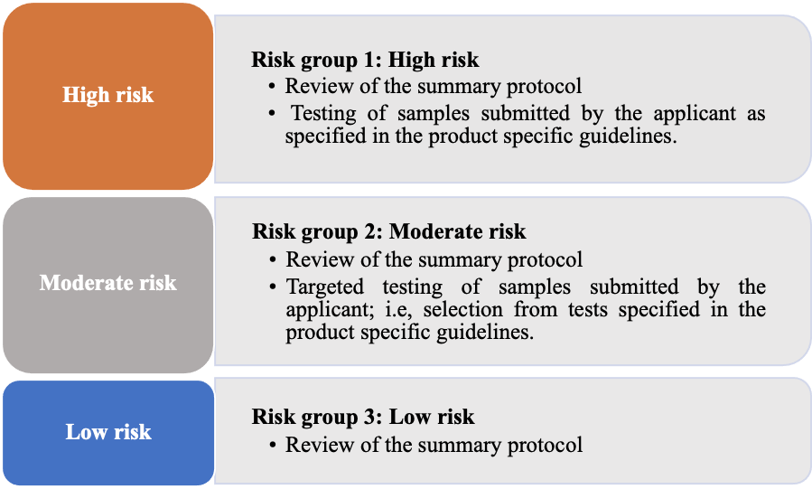
Figure 1: Risk Assessment Tool

II.3.2. Change between risk groups
- ﻿LR procedure may review and update a product risk assessment for the high-risk group if there are reports of significant or severe problems with GMP, adverse events, repeated testing failures, or product recalls.
- Product assignment to risk groups is reviewed annually (as appropriate). Products assigned in risk groups (1 and 2) will be reassigned to the next risk group with lower risk after demonstration of batch consistency and compliance (not less than 20 batches).

II.3.3. Criteria for selection of the testing method
Rwanda FDA laboratory selects a test method from the marketing authorization dossier or equivalent. Critical tests to be considered take into consideration the production specificity, critical quality attributes (CQAs). These CQAs may include appearance, identity, concentration, potency/activity, specific safety, and thermostability (e.g., live vaccines) or level of adsorption.
Key elements of focus for Rwanda FDA laboratory testing will be specified in relevant product type-specific guidelines.
In cases of use of the manufacturer’s methods, the transfer of the method is performed during the process of reviewing product registration (or change) or before the lot release testing application for the first lot.

II.3.3.1. Parallel testing procedure
Under ﻿certain circumstances, the applicant may request lot release testing through the parallel testing procedure, where testing by the Rwanda FDA laboratory is done in parallel with the manufacturer before the latter has completed the quality control testing. In this case, the applicant submits a formal request and labelled samples to the Rwanda FDA laboratory. The approved lot summary protocol is then provided at the completion of the tests by the Quality Control of the manufacturer.
In case the applicant intends to withdraw the lot during the parallel testing procedure due to non-compliance with the specifications during the analytical testing or any other reason, the Rwanda FDA laboratory shall be notified, and the procedure shall be discontinued.

II.3.3.2. Expedited lot release pathway
Expedited release is granted in exceptional cases and upon appropriate justification, such as:
- Critical vaccine and/or other concerned biological product shortage in Rwanda;
- Public health emergency/crisis;
- Donation of vaccines and/or other concerned biological products by international organizations.
Lot release through the expedited pathway is, at a minimum, based on a review of the manufacturer’s lot summary protocol. It also includes a review of the lot release certificate issued by the responsible NRA/NCL (see Appendix IV).

II.3.3.3. Reliance/Recognition Lot Release pathway
Rwanda FDA laboratory releases lots of WHO prequalified or listed under EUL biological products procured and distributed through UN agencies (e.g. UNICEF), donated or self-procured based on either lot summary protocol review and lot release certificate from the responsible NRA or NCL, if available, or by acceptance of the lot without further review of the lot summary protocol. The NRAs that the Rwanda FDA laboratory considers for lot release reliance or recognition are those listed on the WHO website (Appendix V). Testing can be undertaken on the selected lot for the purpose of strengthening the laboratory capacity and obtaining information on the quality of the product. If a deficient result is detected, the responsible NRA/NCL should be consulted.

II.4. Data monitoring
Rwanda FDA laboratory conducts a trend analysis on critical quantitative data from the manufacturer’s quality control results. A statistical analysis is also performed as a long-term comparative trend analysis between the manufacturer and the Rwanda FDA data.

II.5. Evaluation of the lot and the decision-making process
Rwanda FDA laboratory describes the process charts for decision-making (Appendix II). Procedures are available to cover the lot release pathways. The Rwanda FDA laboratory performs relevant laboratory testing and/or document review as per the MA dossier and all approved product variations.
When the lot complies with the release requirements, a certificate is formally issued to the applicant. In the event of non-compliance, a full traceability investigation is conducted, and the applicant is informed as described in Appendix III.

II.6. lot release or lot rejection certificate
A lot release or rejection certificate is issued by the Rwanda FDA laboratory as an official document confirming that a particular lot meets or does not meet the relevant requirements, respectively. It may include information related to the tested parameters, individual results, specifications, etc., and a final decision. (see Annex II).

II.7. Lot release timeline
﻿Lot release process is performed on a “first in, first out” basis with strict adherence to the time frame indicated in the table below. In the case of an unexpected delay due to retesting or delays in the availability of reference materials, delays are communicated to the manufacturer/applicant.
The timeline countdown starts once Rwanda FDA has received a complete set of the application, which consists of relevant documents and samples.

Table 2-Lot Release Time Frames
Process/activity | Time frame
- Standard pathway, high risk products | Within 60 working days
- Standard pathway, moderate risk products | Within 30 working days
- Standard pathway, low risk products | Within 20 working days in case of LSP review only
- Standard pathway, in case of parallel testing | Within 20 working days after receipt of LSP
- Expedited pathway | Within 15 working days when minimal testing is needed  Within 5 working days when no testing is required
- Lot release through reliance | Within 5 working days from the receipt of the release certificate from the relevant NRA
- Lot release through recognition | Within 5-7 working days in case of review of LSP only
- Submission of non-conformity appeal by the manufacturer/applicant | Within 30 working day form the date that it was informed with non- conformity case

II.8. Communication
The manufacturers/applicants communicate with the Rwanda FDA lot release service in case of inquiry or request for clarification regarding the LR process and procedures through the official email at info@rwandafda.gov.rw, with a copy to lotrelease@rwandafda.gov.rw.

chapter III.REQUIREMENTS FOR LOT RELEASE SUBMISSION

III.1. Application submission

﻿All lot release documents are uploaded either to the IRIMS/LIMS of the Rwanda FDA or via the applicant/ manufacturer's own sharepoint site. The applicant and Rwanda FDA arrange easy access to the SharePoint. After the applicant uploads the lot release application documents to SharePoint, he should inform the Rwanda FDA by sending an email to lotrelease@rwandafda.gov.rw containing a list of the uploaded files, the upload date, and the username of the uploader.
All the documents shall be written in one of the official languages. Each document name shall be clearly tagged, indexed, and labelled to indicate the type of product, the corresponding batch number and a short description.
Documents to be submitted with each lot release application are illustrated in Appendix VI according to the type of product to be released.
III.1.1. Application assessment
After submission, the lot release staff checks the completeness of the application. If the application is incomplete, the applicant is informed within 2 working days. Any missing documents or clarifications are submitted by the applicant within 10 working days. In case the applicant did not satisfy the required documents, the application is cancelled.

III.1.2. Samples
The sample size is product-specific and submitted to the Rwanda FDA laboratory by the applicant following the product-specific guidelines.
Samples should be delivered in the correct transport conditions, accompanied by respective storage conditions records, to the Rwanda FDA laboratory. Samples submitted without monitor(s) or with alarmed monitors are not accepted, and replacement samples are provided.
Each dosage container submitted should be labelled with the final labelling unless there are valid reasons stated for not doing so (e.g. in case of parallel testing), in which case a specimen of the final label shall be provided and every dosage container labelled with the name of the product, lot number, dosage and the name of the marketing authorization holder.
Samples from stages other than the final lot stage shall be labelled to clearly indicate the stage of the manufacturing process and the date on which the samples were secured, the name of the product, the batch number (or other appropriate identification), and the name of the marketing authorization holder. In case of blood derivatives, plasma and pool samples are submitted prior to the final product sample or together.

III.1.3. Proof of payment
A proof of payment is provided along with the application dossier for lot release. Fees for lot release are prescribed in the regulation (Regulation on Fees/Tariff) available at the website of Rwanda FDA or provided via a proforma invoice.

CHAPTER IV. REFERENCES
- Guidelines for Independent Lot Release of Vaccines by Regulatory Authorities. Annex 2, Technical Report Series, No.978, WHO 2013.
- Assessment Criteria for National Blood Regulatory Systems, WHO, 2012.
- Good reliance practices in regulation of medical products: high-level principles and considerations, Annex 10, Technical Report Series, No.1033, WHO 2021.
- Official control authority batch release (OCABR) for human biologicals: vaccines, blood and plasma derivatives, EDQM, 2013.

APPENDIXES
Appendix I: Risk assessment tool
Appendix II: Standard lot release process flow
Appendix III: Process flow of the decision-making process for a non-compliant lot
Appendix IV: Expedited lot release process
Appendix V: List of competent regulatory authorities
Appendix VI: Requirements for each lot release application
Annex I: Lot release Application Form
Annex II: Lot release Certificate Format

Appendix I - Risk assessment tool
 |  |  | Risk level
Factors considered |  |  | Low | Medium | High
Product indication | Age of target population | Infant |  |  | √
Product indication | Age of target population | Adult | √
Product indication | Health status | Healthy
Product indication | Health status | Patients | √
Product indication | Population size | Limited use | √
Product indication | Population size | Widespread use |  |  | √
Product nature | Source of raw | Human origin |  |  | √
Product nature | Source of raw | Complex manufacturing process |  | √
Product nature | Source of raw | Small molecule | √
Product qualifications | Country of origin/Registration status | Prequalified/reference country | √
Product qualifications | Country of origin/Registration status | Non-reference |  | √
Product qualifications | Country of origin/Registration status | Local |  |  | √
Product qualifications | Country of origin/Registration status | Non-registed |  |  | √
Inspection history |  | Observation & recommendation |  | √
 |  | Quality/safety issues |  |  | √
Testing history |  | Out of trend |  | √
 |  | Non-compliance |  |  | √
Post Marketing experience |  | REMS listing/serious ADRS | √
 |  | Complaints |  | √
 |  | Recalls/ withdrawal |  |  | √

Product category | Total score
Low Risk | ≤ 6
Medium Risk | 7-17
High Risk | > 17

Format: QMS/FMT/002  Revision No:  Effective Date: |  | Department/Division/Office/Unit | Laboratory Service Department
Document Type: Process Flow Chart |  |  | Doc. No | :QCL/CHT/
 | Title: Standard lot release process flow |  | Revision Number | :
 |  |  | Revision Date: | :
 |  |  | Effective Date | :
 |  |  | Review Due Date | :
 |  |  | Ref Doc. | :
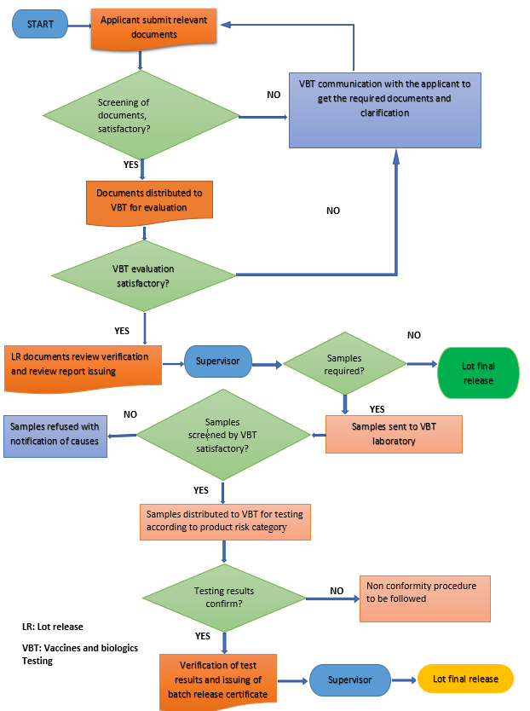

 |  | Department/Division/Office/Unit | Laboratory Service Department
Document Type: Process Flow Chart  Format: QMS/FMT/002  Revision No:  Effective Date: |  |  | Doc. No | :LSD/CHT/
 | Title: Process flow of the decision-making process for non-compliant lot |  | Revision Number | :
 |  |  | Revision Date: | :
 |  |  | Effective Date | :
 |  |  | Review Due Date | :
 |  |  | Ref Doc. | :
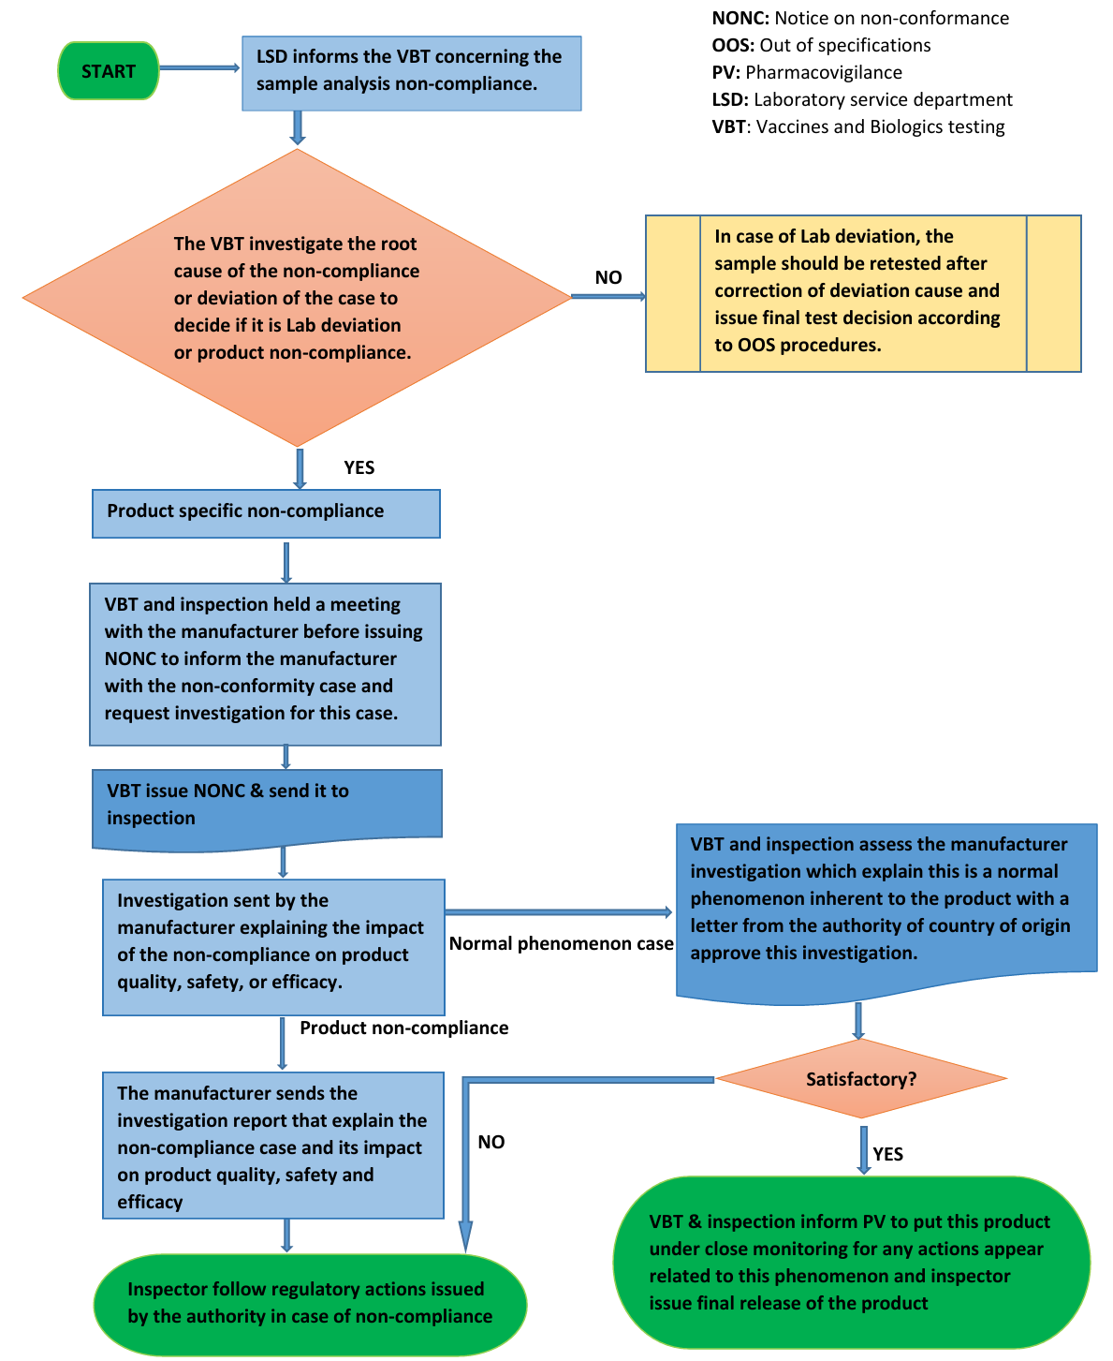
Format: QMS/FMT/002  Revision No:  Effective Date: |  | Department/Division/Office/Unit | Laboratory Service Department
Document Type: Process Flow Chart |  |  | Doc. No | :QCL/CHT/002
 | Title: Expedited lot release process |  | Revision Number | : 2
 |  |  | Revision Date: | :
 |  |  | Effective Date | :
 |  |  | Review Due Date | :
 |  |  | Ref Doc. | :
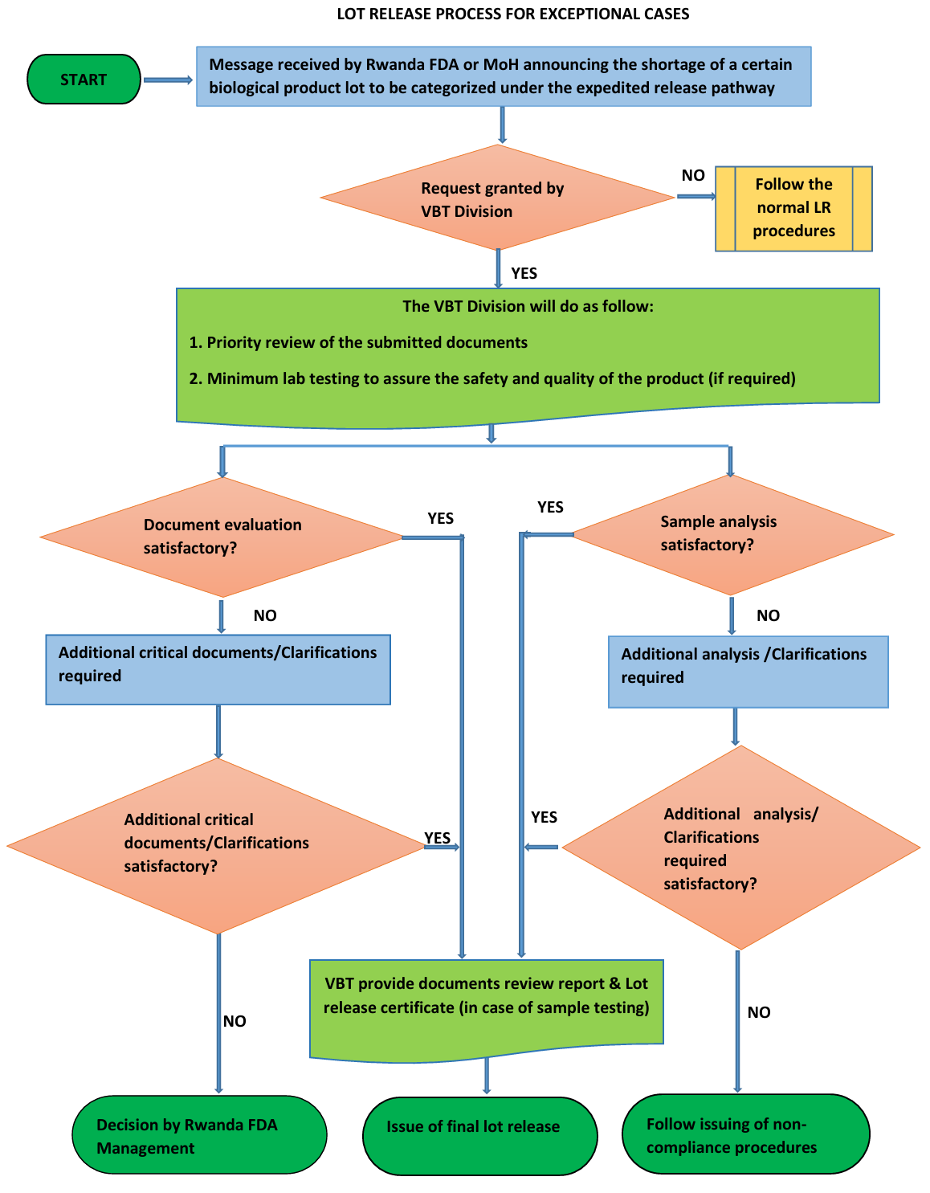
Appendix V. List of competent regulatory authorities 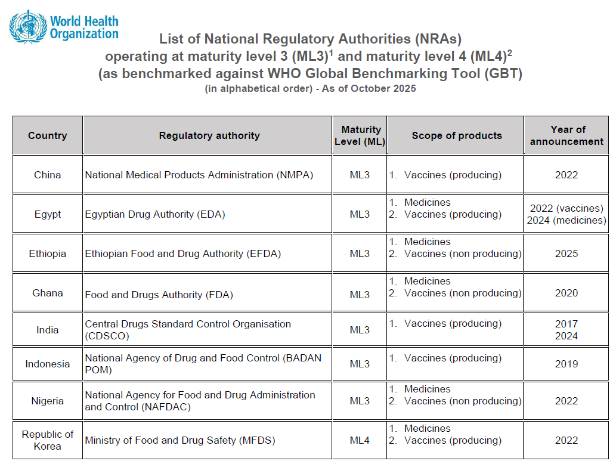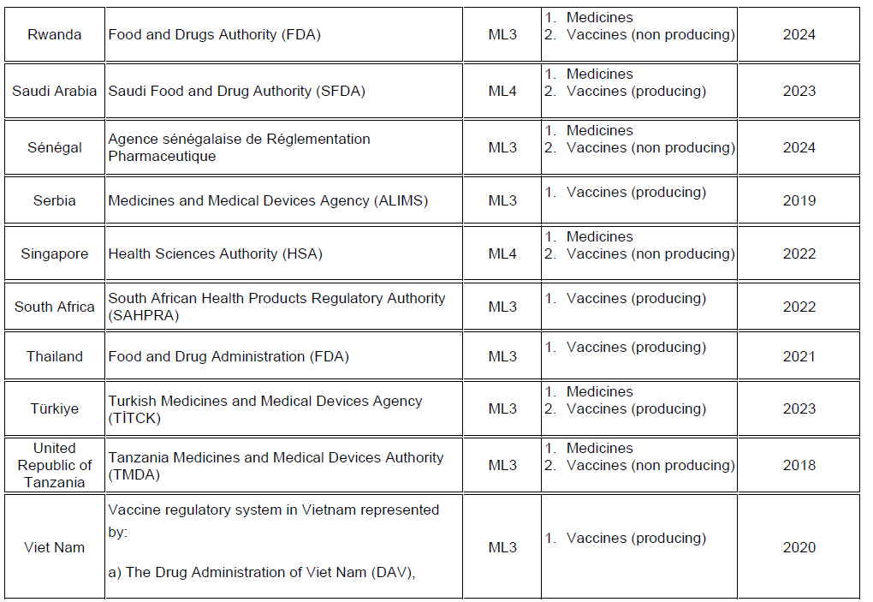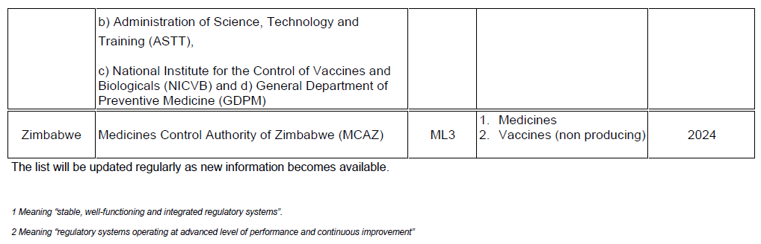

See: https://cdn.who.int/media/docs/default-source/medicines/regulatory-systems/wla/list-of-nras-operating-at-ml3-and-ml4.pdf?sfvrsn=ee93064f_23&download=true (Accessed: 17th December 2025)

Appendix VI - Requirements for each lot release application

- Standard lot release pathway | - Vaccines
- Standard lot release pathway | - Lot release application form (AnnexI)  - Lot Summary Protocol of the biological product during manufacture processes, and testing records and the certificate of analysis. The LSP shall be relevant to the specific format and file names shall contain the product name and lot number (e.g., Vaccine_ABC123_protocol.pdf);  - Lot Release certificate from the releasing NRA for imported products. Where possible, it shall be accompanied by the respective test reports;  - Proof of correct shipment conditions of test samples  - Certificate of analysis of diluent (if applicable);  - Proof of Payment  - Annual quality product review, when required.  - In case of products using albumin as stabilizer, the applicant shall submit:  - NRA lot release certificate for albumin batch used from country of origin,  - Certificate of analysis of finished product for the batch used from the manufacturing company,  - Declaration on link between albumin batch used in the production and the batch of finished product.
- Standard lot release pathway | - Plasma Derived Medicinal Products
- Standard lot release pathway | - All documents that mentioned under vaccines shall also be submitted and the following documents;  - Certificate of release of plasma Pool form releasing NRA in case of imported products;  - Viral Inactivation Certificate for the product;  - TSE Certificate of the batch, in case of products extracted from animal origin.
- Expedited release pathway | - Lot release application form;  - Lot Summary Protocol of the product during manufacture processes, and testing records and the certificate of analysis;  - Lot Release certificate from the releasing NRA for imported products; Where possible, it shall be accompanied by the respective test reports;  - Proof of correct shipment conditions of test samples, where applicable.  - Proof of payment, where applicable
- Reliance/Recognition | - Lot release application form;  - Lot Summary Protocol, where applicable;  - Lot Release certificate from the releasing NRA and respective test reports, where applicable;  - Proof of payment, where applicable

Annex I: Lot release Application Form

Format: QMS/FMT/002  Revision No: 1  Effective Date: 20 June 2022 | Department/Division/Office/Unit | Laboratory Services Department
Document Type: Form |  | Doc. No | : LSD/FOM/059
 | Title:  Lot Release Request Form | Revision Number | : 0
 | Title:  Lot Release Request Form | Revision Date | : 10/10/2022
 | Title:  Lot Release Request Form | Effective Date | : 15/10/2022
 | Title:  Lot Release Request Form | Review Due Date | : 15/10/2023

To: Rwanda FDA Laboratory Services Department Reference No. _______________
Rwanda Food and Drugs Authority Date: ______________________
Nyarutarama Plaza, KG 9 Avenue
KIGALI

Please issue the lot release certificate in respect of vaccines and other biological products as detailed below. All the required documents are enclosed.
- Importer/ manufacturer details
Name and address of the importer/manufacturer

Commercial invoice No.
Invoice date
Shipment reception date
Date of endorsement of invoice
Shipment mod
Port of shipment reception
Name and address of the indent holder (if applicable)
- Product details
Product trade name
Product common name
Registration No.
Lot No.
Manufacturing date (dd/mm/yyyy)
Start date of validity (dd/mm/yyyy)
Expiry date (dd/mm/yyyy)
Storage temp.
Transportation temp.
Manufacturer | Name
Manufacturer | Address
Pharmaceutical dosage form
Type of container
Number of doses per container
Strength / quantity per container
Transportation/storage data evidence
Quantity applied for lot release
- Solvent / diluent details (in case of freeze dried product)
Solvent/ diluent name
Lot No.
Type of container
Volume per container
Registration No.
Mfg. Date
Exp. Date
Name & address of the manufacturer

- Lot Release requested by authorized person
Name
Designation
Signature
Date
Telephone No.
Cell No.
Name of the firm / pharmaceutical company
Complete address
Official stamp

- Required documentation
Refer to the Guideline.

- Responsible person confirmation
I hereby declare that I have inspected all lot documents and confirm that the product(s) has (have) been manufactured, inspected, and meet the requirements in accordance with marketing authorization.

Date
Name and signature of the responsible person:

For Official Use only:

1. | Summary protocol received |  |  |  |  |  | □ Yes |  | □ No
2. | Lot release certificate from NRA of exporting country received (in case of imported products) |  |  |  |  |  | □ Yes |  | □No Exemption Certificate
3. | Batch production record received (for locally manufactured products). |  |  |  |  |  | □ Yes |  | □ No
4. | Copy of the registration letter received. |  |  |  |  |  | □ Yes |  | □ No
5. | Copy of the endorsed paid bank receipt received. |  |  |  |  |  | □ Yes |  | □ No
6. | Copy of endorsed invoice received |  |  |  |  |  | □ Yes |  | □ No
Reception date |  |  |  |  | Received by (sign)
Application accepted |  | □ Yes |  |  | Name
If rejected (reason) |  |  |  |  | Designation
Assessment required |  |  |  | □ Summary protocol review |  |  |  | □ Laboratory Access
Assigned reviewer
Deadline for assessment

Annex II: Lot Release Certificate Format

ENDORSEMENT OF THE GUIDELINES

 | Prepared by | Checked by |  | Approved by
Title | Division manager for VBT | Head of Department | Division Manager for QMS | Director General
Names | Dr. Peter RWIBASIRA | Prof. Raymond MUGANGA | Ms. Marie Ange UWASE | Prof. Emile BIENVENUE
Date & Signature

