

GUIDELINES FOR RECALL, TREATMENT AND DISPOSAL OF SUBSTANDARD AND FALSIFIED PHARMACEUTICAL PRODUCTS AND MEDICAL DEVICES INCLUDING IN-VITRO DIAGNOSTICS (IVDS)

JANUARY, 2026

FOREWORD

Rwanda Food and Drug Authority (Rwanda FDA) is a regulatory body established by the law N°003/2018 of 09/02/2018, whereby the management of substandard and falsified Medical products, post marketing surveillance and safety monitoring are among the functions of Rwanda FDA as it is provided for the above law especially in its article 3 paragraph 9 and 11.

Considering the provisions of the regulations Nº.: CBD/TRG/019, Governing Recall, Treatment and Disposal of Unfit Products, Rwanda FDA issues these Guidelines on Recall, Treatment and Disposal of substandard and falsified Pharmaceutical Product and medical devices including in-vitro diagnostics (IVDs).

When Medical products are suspected of being potentially harmful to users due to their defective quality, safety or efficacy and are particularly suspected to be substandard and falsified or unregistered / unlicensed they may be subjected to a recall. Recall is therefore, an effective method of removing specific batch or batches of medical products from the market due to the public health protection against suspected substandard and falsified products.

These Guidelines for recall, treatment and disposal of substandard and falsified Pharmaceutical Product and medical devices including in-vitro diagnostics (IVDs) intend to put in place a process for recall and to ensure that the recall procedures are effectively and efficiently carried out. They also provide guidance to all stakeholders handling medical products to ensure safe disposal of substandard and falsified medical products and prevent re-entry of the product into the supply chain.

Rwanda FDA acknowledges all the efforts of key stakeholders who participated in the development and validation of these Guidelines.

Prof. Emile BIENVENU
Director General

DOCUMENT DEVELOPMENT HISTORY

First issue date | 05/02/2021
Effective date of this revision | Refer to the approval date

Document Revision History

Date of revision | Version number | Changes made and/or reasons for revision
05/02/2021 | 1 | First issue
12/11/2021 | 2 | - The table of glossary was updated to include the definition of unfit pharmaceutical products and other definitions related to methods of disposal were included  - Section 4.2 of Methods of Disposal was included  - Provisions for safe disposal /destructions investigational products  - The word Rwanda FDA was replaced by Rwanda FDA were applicable  - Specific Section of requirement regarding safe disposal of unused investigational products  - Chapter 5 was deleted  - Application form for safe disposal of investigational product included  - The form for disposal of unfit investigational products included  - Necessary editorial changes and formatting were made;
15/01/2026 | 3 | - Alignment with the new organizational structure of Rwanda FDA  - Alignment with the new QMS format  - Updating the title of the guidelines and becaming Guidelines for Recall, Treatment and disposal of substandard and falsified pharmaceutical products and medical devices including in-vitro diagnostics (IVDs)  - The table of glossary was updated to include other definitions  - Term Unfit products was totally replaced by Substandard and falsified pharmaceutical products and medical devices including IVDs  - Addition of provisions outlining the roles and responsibilities of local manufacturers in Rwanda for the effective implementation of recall procedures  - Adding clear timelines for recall related activities such as timelines for disposal of recalled pharmaceutical products and medical devices including in-vitro diagnostics (IVDs) and timelines for submission of report on refund  - Replacing the section on recall evaluation and effectiveness checks with a new section titled “Monitoring and Recall Audit”  - Adding provisions on the proper storage of products placed under quarantine.  - Clear procedures for health risk evaluation, risk reporting, and follow-up with consumers/patients  - Editorial and formatting changes were made as needed in accordance with the current document control SOP

TABLE OF CONTENTS
FOREWORD 2
DOCUMENT DEVELOPMENT HISTORY 3
Document Revision History 3
TABLE OF CONTENTS 5
ACRONYMS AND ABBREVIATIONS 7
GLOSSARY / Definitions 8
CHAPTER I. INTRODUCTION 10
I.1 SCOPE 10
CHAPTER II. RESPONSIBILITIES & REQUIREMENTS 11
II.1 Responsibilities of Manufacturers, importers, Distributors, Local Technical representatives and MAH 11
II.2 The requirements and responsibilities of Rwanda FDA 11
II.3 Management of medical products called for quarantine 12
CHAPTER III: RECALL 12
3.1 Voluntary Recall 12
3.2 Statutory recall (Non-Voluntary) 13
3.3 Recall classification 13
3.4 Management of recalled medical products. 14
3.5 Levels, depth and action for the recall 14
3.6 Recall timelines 15
3.7 Recall Communication 15
3.8.1 Communication to the public by recall letters 15
3.8.2 Rapid alert system 16
3.8.2.1 Procedure for Rapid Alert and Recall System 16
III.2 Monitoring and recall audit 17
IV.2 Investigation of the reasons for the recall and initiation of remedial action 18
3.1 Refund mechanism and Post recall 18
3.16 Termination of product recall 19
3.18 Health risk evaluation 19
3.19 Reporting of risk and follow up to consumers/patients 19
CHAPTER IV: TREATMENT AND DISPOSAL OF substandard and falsified PHARMACEUTICAL PRODUCTS AND MEDICAL DEVICES INCLUDING IN-VITRO DIAGNOSTICS 20
4.1 Treatment and handling of substandard and falsified of pharmaceutical products and medical devices including IVDs 20
4.2 General requirements for disposal of substandard and falsified of pharmaceutical products and medical devices including IVDs 20
4.3 Specific Requirements for disposal of substandard and falsified medical products 22
4.4 Safe Disposal of Expired, Damaged, Improperly Stored, Improperly Labelled, Adulterated, Prohibited, Unauthorized and Other Non-Compliant Regulated Products 22
4.5 Specific Requirements for safe disposal of unused investigational products 22
ENDORSEMENT OF THE GUIDELINES 23
APPENDICES 24
ANNEX 1. REQUEST FORM FOR DISPOSAL OF SUBSTANDARD AND FALSIFIED PRODUCTS 25
ANNEX 2. VERIFICATION FORM FOR A REQUEST FOR DISPOSAL OF SUBSTANDARD AND FALSIFIED PRODUCTS 27
ANNEX 3. REGISTER FORM FOR SUBSTANDARD AND FALSIFIED PHARMACEUTICAL PRODUCTS 29
ANNEX 4. ADVERSE DRUG EVENT REPORTING FORM 30
ANNEX 5. FORM FOR DISPOSAL OF UNFIT INVESTIGATIONAL PRODUCT 33
ANNEX 6. REGISTER FOR DISPOSAL OF UNFIT INVESTIGATIONAL PRODUCT 35

ACRONYMS AND ABBREVIATIONS

CRO | Contract research organization
LTR | Local Technical Representative
GMP | Good Manufacturing Practice
HCPs | Health care providers
IP | Investigational product
MAH | Marketing Authorization Holders
PI | Principal investigator
Rwanda FDA | Rwanda Food and Drugs Authority

GLOSSARY / Definitions

“Authority” means Rwanda Food and Drugs Authority, or its acronym “Rwanda FDA” established under Article 2 of Law Nº 003/2018 of 09/02/2018.

“Disposal” means the process of rendering harmless any unwanted or substandard and falsified regulated product.

“High Temperature Incinerator” means an incinerator that generates at least 1200°C in the secondary chamber, and is fitted with gas cleaning equipment.

‘’Investigational Product” Any regulated products being tested or used as a reference in a clinical trial (animal and human), including a product with a marketing authorization when used or assembled (formulated or packaged) in a way different from the approved form, or when used for an unapproved indication, or when used to gain further information about an approved use.

“Medical products” Any medicine or similar product intended for human use, which is subject to control under health legislation in the manufacturing or importing State
Includes human and veterinary drugs; human and animal vaccines and other biological products, poisonous substances, herbal medicines, medicated cosmetics, laboratory and household chemicals and pesticides.

“Pharmaceutical Products” Any substance capable of preventing, treating human or animal diseases and any other substance intended for administration to a human being or an animal in order to diagnose diseases, restore, correct or carry out modification of organic or mental functions. It also means all medicated cosmetics and veterinary products and products used for disinfecting premises where food and drugs are manufactured, prepared or stored, cleaning hospitals, equipment and farm houses;

“Medium Temperature Incinerator” means a two-chamber incinerator with minimum temperature of 850ºC.

“Open Controlled landfill” means a landfill where medicines waste is covered with large amount of municipal wastes but it is still left open.

“Open uncontrolled landfill” means a landfill where medicines waste is not covered with large amount of municipal wastes and it is left open.

“Product recall” means a process for withdrawing or removing a medical product from the supply chain because of defects in the product, complaints of serious adverse reactions to the product, unauthorized entry on to the market and/or concerns that the product is or may be substandard and/or falsified. The recall might be initiated by the manufacturer, importer, Local Technical Representative (LTR) wholesaler, distributor or Rwanda FDA.;

“Quarantine”: The status of medical products isolated physically due to suspicion on the quality or safety, while a decision is wait on their release, recall, and rejection or reprocessing. Quarantine status is ensured by storage in separate areas, these areas must be clearly marked and access limited to only authorized personnel.

“Recall strategy" means a planned specific course of action to be taken in conducting a specific recall, which addresses itself to matters such as the depth of recall, need for public warnings, and extent or effectiveness checks for the recall

“Recalling entity” as used in this document refers to the legal party that initiates or is instructed to initiate a recall. It is usually the entity that has primary responsibility for the manufacture, importation, distribution, or is the marketing authorization holder.

“Sewer” means a flushing of medicines wastes to the sewerage system after proper dilution and regulation.

“Statutory recall” as used in this document refers to when Rwanda FDA requests or orders a product recall due to non-compliance to regulatory requirements.

“Substandard and falsified medical products”
Falsified Pharmaceutical products: Pharmaceutical products that deliberately/fraudulently misrepresent their identity, composition or source;
Substandard Pharmaceutical products: Also called “out of specification”, these are authorized Pharmaceutical products that fail to meet either their quality standards or their specifications, or both;

“Voluntary Recall” as used in this document refers to when a manufacturer, importer, distributor, or marketing authorization holder requests a product recall after discovery of safety concerns, product defects or non-compliance to regulatory requirements.

“Waste Encapsulation” means a landfill approach to reduce the risk of medicine waste through immobilizing the medicine in a solid block within a plastic or steel

“Waste Inertization” means a variant of encapsulation and involves removing the packaging materials including blister packs, paper, cardboard and plastic from the medicines and then crushing and mixing medicines with cement, lime and water.

“Withdrawal or cancellation of registration “means the total removal of a medical product from the market that could be due to an irreversible quality, safety or efficacy concern due to published research findings or non-compliance to Good Manufacturing Practices.

INTRODUCTION

Ensuring the safety, efficacy and quality of medical products is a prime responsibility of the manufacturers and distributors of medical products. The responsibility is shared with the Rwanda Food and Drugs Authority (Rwanda FDA).
When medical products are suspected of being potentially harmful to users due to their defective quality, safety or efficacy, they may be subjected to a recall and all related information must be reported to Rwanda FDA.
A recall will be terminated when Rwanda FDA and the recalling entities are in agreement that the medical product which was recalled has been removed from the market and proper disposal has been made following all requirements of treatment and disposal of substandard and falsified medical products stipulated by these guidelines.

SCOPE

These Guidelines apply to all manufacturers, importers, exporters, distributors, CROs and clinical trial sites and retailers of medical products that are found to be substandard and falsified, in order to explain and standardize the procedure for medical products recall in order to ensure effective removal and safe disposal of substandard and falsified medical products from the market including disposal of any unused quantities of investigational products and to provide guidance of handling in order to prevent its re-entry into the supply chain.

RESPONSIBILITIES & REQUIREMENTS

Responsibilities of Manufacturers, importers, Distributors, Local Technical representatives and MAH

The Responsibilities of Manufacturers, importers, distributors, Local Technical representatives and marketing authorization holders include the following:
    - Maintaining records and establishing procedures which assist in facilitating the recall;
    - Establishing and Maintaining documented post-market surveillance and vigilance systems to detect device malfunctions, performance failures, and adverse events;
    - Taking the prime responsibility in implementing the recall;
    - Having written procedures in place which are consistent with the guidelines and which are applicable to their own operations;
    - Further investigating the case of a defective product and recalls as well as providing the corrective and preventive actions.
    - Initiation of voluntary recall which is the recalling of a product at the entity’s sole responsibility to request and implement the recall process by contacting all companies and facilities to whom the recall products have been distributed and ensuring the physical removal of the products from the market to the level required. In such cases prior notice should be given to Rwanda FDA.
    - In case of a recall involving products manufactured in Rwanda, the local manufacturer must act quickly informing Rwanda FDA. If the products were exported, foreign regulatory authorities are also notified by manufacturer. Finally, the manufacturer shall provide to Rwanda FDA the proof that the recall has been fully implemented both locally and internationally.

The requirements and responsibilities of Rwanda FDA

The requirements and responsibilities of Rwanda FDA include the following:
    - Initiation of Statutory-Recall (Non-Voluntary): Rwanda FDA shall be responsible for issuing a product recall, or instructing the Marketing Authorization Holder (MAH), importer, or distributor to initiate a recall when a product’s registration is cancelled for safety reasons, or when the product fails to meet regulatory requirements. Rwanda FDA shall also ensure that such information is communicated to the general public.

    - In such instances, Rwanda FDA shall monitor the effectiveness of the recalling entity’s actions and provide scientific, technical and operational advice where necessary.

    - If the recalling entity’s actions are deemed inadequate, Rwanda FDA may take appropriate actions to remove the product from sale or use. The recalling entity’s recall does not preclude enforcement actions being taken by Rwanda FDA as deemed appropriate, either during or following the completion of a recall.

    - Issue a call for quarantine due to the following reasons:
      - while the investigation on quality and safety of given medical products is ongoing;
      - When Rwanda FDA receive reports on quality defect of medical products which are suspected to harm the life of a consumer and need further investigations;
      - Anytime Rwanda FDA is conducting deep investigation on quality and safety of medical products due to suspicion of poor quality of products and due to serious adverse drug events associated to the use of medical products.

Management of medical products called for quarantine

The management of pharmaceutical products called for quarantine must comply with the following:

    - Where quarantine status is ensured by storage in separate areas, the areas must be clearly marked and access restricted to authorized personnel. Any system replacing physical quarantine should provide equivalent security. For example, computerized systems can be used, provided that they are validated to demonstrate security of access;
    - All medical products that were called for quarantine must be quarantined at the level where they were when the call for quarantine was issued. Quarantined medical products should be identified and controlled under a quarantine system designed to prevent their use until a final decision is made.
    - The quarantined medical products must be stored following good storage practices in accordance with Rwanda FDA Regulations No: DD/PIL/TRG/006 Governing Good Storage and Distribution Practices of Medical Products. This is important because quarantined products may be returned to the market after investigations are completed and confirm that they meet the required quality standards.

CHAPTER III: RECALL

Any medical product / batch (es) not meeting the defined quality standards have to be recalled from the market. Recall can be of two types: Voluntary Recall and Statutory Recall.

Voluntary Recall

Voluntary recall may be triggered by any incident that affects the quality, safety and efficacy of the batch/product in question such as:
    - Batch(es) not complying with regulatory specifications during the post marketing stability study;
    - Batch (es) found to be defective during investigation of market complaint;
    - During any failure investigation, if it is observed that the failure under investigation might have adverse quality impact on already released batch (e.g. possibility of contamination, mix-up, degradation etc.);
    - If any unusual observation is noted during visual inspection of retention samples which indicate an impact on quality of the product after investigation;
    - If the post marketing surveillance reports /pharmacovigilance reports indicates that there is serious safety risk associated with the product.
    - Voluntary recall could be done by Manufacturers, importers, Distributors, Local Technical representatives and MAH after notifying Rwanda FDA in respect of recall classifications’timelines prescribed by these guidelines

Statutory recall (Non-Voluntary)

Statutory recall of medical products or batch (es) from the market by Rwanda FDA may be triggered by the:
    - A medical product or batch identified as not meeting quality standards, including substandard or falsified medical products.
    - Reports of serious adverse drug reactions not included in the package insert;
    - Unexpected frequency of adverse reaction stated in the package insert;
    - Presence of products banned by Rwanda FDA;
    - Medical products for which the marketing authorization has been withdrawn/cancelled;
    - Labelling and/or promotional materials that are considered to be in violation of regulations issued by Rwanda FDA.

Recall classification

Rwanda FDA shall assign a designation number, i.e. I, II or III, to a particular product recall to indicate the relative degree of health risk presented by the product being recalled. The following classifications shall apply:

Class I: is for defective, dangerous or potentially life threatening substandard and falsified medical products that predictably or probably could result into serious health risk or adverse events or death; Examples include but not limited to:
- Wrong product (label and content are different products);
- Correct product but wrong strength;
- Microbial contamination of sterile product;
- Contamination with another chemical with serious health consequences
- Wrong active ingredient;
- Non-compliance with specification (e.g. assay)
- Product mix up.
Class II: is for substandard and falsified medical products that possibly could cause temporary or medically reversible adverse health problem or mistreatment; Examples include but not limited to:
- Mislabelling e.g. wrong or missing text or figures;
- Missing or incorrect information- leaflets or inserts with packing;
- Microbial contamination of non-sterile products
- Chemical/ physical contamination (significant impurities, cross contamination, particulates);
- Mix up of products in containers;
- Non-compliance with specification (stability, fill/ weight or dissolution);
- Insecure closure with serious medical consequences (e.g. cytotoxins, child resistant containers, potent products, toxic chemicals).
Class III: is for substandard and falsified medical products that are defective and are unlikely to cause any adverse health reaction or which do not comply with the requirements for the printed packaging material, product specification or labeling. Examples include but not limited to:
- Faulty packaging e.g. wrong or missing batch number or expiry date
- Faulty closure not resulting in any medical consequences
- Contamination with no medical consequences (e.g. dirt or detritus among others).

Management of recalled medical products.
    - All recalled pharmaceutical products must be clearly recorded and returned to the local supplier according to the physical recall timeline as per table established in section 3.6.
    - The suppliers with recalled pharmaceuticals products shall report to Rwanda FDA the quantities imported per product, quantities distributed, quantities returned and final stock on hand of recalled Pharmaceutical products within 5 days upon completion of physical recall timeline.

Levels, depth and action for the recall

The level (or depth) of recall of medical product/batch shall be determined based on recall classification and level to which distribution has taken place.
There are three levels of recall namely, consumer/user, retail and wholesale levels:
    - Wholesale level includes all parties involved in wholesale distribution of medical products.
    - Retail level includes all public and private hospitals; retail pharmacies; clinical investigators and the institutions in which clinical investigations are performed; medical, dental and other health care practitioners; nursing homes and other related institutions; other retail outlets dealing with medical products.
    - Consumer level includes patients and other consumers.

Recall level | Depth | Action
Wholesale Level | Recall is designed to reach wholesale level and other distribution points. This can be achieved by means of representatives calling on Wholesalers and/or retail outlets.  If it is known where the product in question had been distributed to, specific telephone calls or recall letters to arrange for the return of the product could be made. | Recall letter to manufacturers, importers/wholesalers
Retail Level / User facilities | Recall is designed to reach wholesalers, hospital pharmacies (private / public hospitals),  retail outlets | Recall letter to manufacturers /  importers and HCPs
Consumer or User Level | Recall is designed to reach all suppliers of Medicines (all distribution points) i.e. wholesalers, hospitals pharmacies (private / public hospitals), retail outlets, and individual  customers or patients through media release (TV, radio, print media, social media etc.) | Recall letter to manufacturer/importer to be initiated at all levels of distribution Plus media release.

Recall timelines

    - All Class I recalls shall be executed to the levels of Wholesale/Distributors, retail, and consumer. In such cases, public announcements shall be made using recall notification letters/Rwanda FDA website, social media platforms, newspapers, television, radio among others;
    - All Class II recalls shall be executed up to the levels of wholesale and retail; and
    - All Class III recalls shall be executed up to the levels of wholesale.
The Rwanda FDA retains full responsibility for determining the appropriate recipients of recall notifications, based on the nature and severity of the quality defect in the recalled products.

The following timelines shall apply to medical products recalls, the timeline for initiating and stopping sale/distribution of defective medical product:

Recall Class | Initiation Timeline | Physical Recall Timeline | Reporting timeline upon completion of physical recall
Class I | 24 Hours | 72 Hours | 5 days
Class II | 48 Hours | Up to 10 Days | 5 days
Class III | 72 Hours | Up to 30 Days | 5 days

Recall Communication

A recalling entity is responsible for promptly notifying each of its affected distribution outlets about the recall. The format, content, and extent of a recall communication should commensurate with the hazard of the medical product and the strategy developed for that recall. Rwanda FDA shall ensure that recall communications reach all relevant stakeholders in accordance with the level of the recall, including the wholesale level, retail level/user facilities, and the consumer or end-user level. As determined by the recall strategy, a recall communication can be accomplished by: Telephone, SMS, email, social media and announcement.

Recall communication should convey:
    - That the medical product in question is subject to a recall;
    - That further distribution or use of any remaining product should cease immediately;
    - Instructions regarding what to do with the medical product.

Communication to the public by recall letters

In the event of a recall, the recalling entity may prepare letters with a factual statement of the reasons for the recall of the product, together with specific details that will allow to be easily identified.
The recall communication cannot contain any material that can be viewed as promotional in nature. The letter can be sent by standard means of communication such as mail, Proof of delivery or acknowledgement of receipt.
The recall letter needs prior approval by Rwanda FDA unless the matter is urgent and there is immediate hazard or risk to the consuming public.

The recall letter should use the company/Authority letter head, include the date, name and title of signatory.

The contents may include:
    - A description of the medical product: name of the product, name of manufacturer, Manufacturing date, registration details, pack size, dosage form, batch number(s) and expiry date(s).
    - Hazard and risk associated with the product: The reason for the recall should be concisely explained. It should be explained that further distribution or use of the product should cease immediately.
    - Instruction for recall of the product: The method of return, disposal and refund mechanism.
If safety of the public is involved and distribution is limited, the recalling entity may disseminate the information above by telephone which can then be followed by a recall letter.

Rapid alert system

This procedure covers the transmission of information when urgent action is required to protect public or health by means of a rapid alert relating to the recall or withdrawal of medicinal products, which have quality defects or which are falsified, the aim of the Rapid Alert System is to transmit those alerts whose urgency and seriousness cannot permit any delay in transmission.

Rapid alert to the public is usually reserved for Class I recall and Class II recalls where appropriate, or situations where other means of controlling the hazard appear inadequate. Rapid alerts to the public may be issued through appropriate channels which may include telephone, social media, emails to PMS stakeholders and to other National Regulatory Authorities, reporting to WHO using Global Surveillance and Monitoring System(GSMS) and a press release approved by Rwanda FDA

All press release statements associated with a product defect and recall must be approved by Rwanda FDA prior to publication or release in the press to avoid unnecessary panic to the public and consumers; or miscommunications.
Information that should be included in the press statement is:
    - A clear outline of the problem;
    - Clear product information identifying product use;
    - Possible effects (without alarming or causing fear to the consumer);
    - What the consumer should do;
    - Company information and contact details of the responsible person(s).

Procedure for Rapid Alert and Recall System
The following steps shall be taken when a recall is initiated:
      - In case of voluntary recall, as soon as the medical product batch (es) to be recalled is/are identified, the Market Authorization Holder (MAH) or local agent in charge shall review the information related to the defective medical product/batch(es) and decide about recall as per the procedure established in section 3.1 of these guidelines.
      - The decision on recall of the defective medical product/batch shall be made within 24 hours up to maximum of 72 hours for Class I recall upon receipt of the recall information.
      - Within 24 hours of the decision taken for the recall of the medical product/batch(es), the communication shall be sent stating the severity of the defect, using the fastest mode of communication which may include telephone, social media, emails to PMS stakeholders and to other National Regulatory Authorities, reporting to WHO using Global Surveillance and Monitoring System(GSMS) and a press release approved by Rwanda FDA
      - The Manufacturer, Marketing Authorisation Holder/Local Agent where the medical product is marketed shall inform the concerned regulatory authorities where the recalled medical product batch (es) was distributed immediately after the decision of recall has been taken.
      - It is the responsibility of the recalling entity (Manufacturer, Marketing Authorisation Holder, / Local agent) to immediately notify distributors to suspend sale and/or further distribution of the recalled medical product after discovering the problem.
      - Details of notification shall include but not limited to:
      - Name, strength, batch and any other pertinent descriptive information of the product;
      - Reason for the recall;
      - Suggested action to be taken and its urgency;
      - Provide specific instructions on what should be done with the recalled medical product;
      - Follow-up communications should be sent to those who fail to respond to the initial recall communication;
      - Records detailing recalled medical products including available stock and returned stock from various outlets shall be maintained by the recalling entity and shall be made available for verification by Rwanda FDA.

  - Monitoring and recall audit

It is the responsibility of Rwanda FDA and the recalling entity to ensure that the recall is effective through a well-coordinated recall audit. The recall audit should be conducted within ninety (90) calendar days. The purpose of recall audit is to verify that all affected distribution outlets identified have received notification about the recall and have taken appropriate actions. The check on the level of effectiveness of the recall shall be conducted as follows:
a) Consumer/user Level - 100 percent of the total number of distribution outlets to be contacted;
b) Retail Level- percentage greater than 20% of the total number of distribution outlets to be contacted, percentage is to be determined on a case by case basis.
c) Wholesale Level – 50 percent or greater of the total number of distribution outlets to be contacted, percentage is to be determined on a case-by-case basis.

If a recall is found to be ineffective, Rwanda FDA shall take appropriate regulatory actions including to request the recalling entity to take additional actions.

  - Investigation of the reasons for the recall and initiation of remedial action

On completion of a recall, the recalling entity shall provide a report of the investigation of the problem and details of the remedial action proposed to prevent a recurrence of the problem which gave rise to the recall. Where the nature of the problem and appropriate remedial action are not apparent, Rwanda FDA shall conduct the investigation and in some cases site inspections e.g. GMP inspections may be necessary.

  - Refund mechanism and Post recall

The manufacturer, marketing authorization holder, local technical representative, importer, distributor, or any other supplier of recalled products shall ensure that all persons affected by the recall are provided with a full and transparent refund. To support this, they shall establish and implement a comprehensive refund mechanism that clearly outlines the procedures for submitting refund requests, the timelines for processing such requests, and the methods of reimbursement. This mechanism shall apply to all relevant PMS stakeholders, including wholesalers, retailers, healthcare facilities, and consumers who have received the recalled products.

Furthermore, the manufacturer, marketing authorization holder, local technical representative, importer, distributor, or any other supplier of recalled products shall submit to Rwanda FDA using official communication channels a detailed reimbursement report within sixty (60) days from the initiation of the recall. This report shall include, among other elements, the number of organizations or individuals to whom the defective product was supplied, the date and method used to communicate the recall, the number of responses received, and the identification of non-responders. It shall also provide quantitative data, including the total quantity of the recalled products manufactured or imported, the quantity distributed, the quantity returned, and the quantity remaining in stock at the time of the recall that was subsequently removed from circulation. In addition, the report shall include evidence demonstrating that recall communications were effectively disseminated to all affected clients.

All refund transactions shall be properly documented and maintained in an organized manner. These records shall be made readily available for regulatory inspection to demonstrate compliance with the recall and reimbursement requirements.

After recall, the recalling entity shall notify Rwanda FDA based on recall classification timeline in writing with the recall information including:
    - Name, strength, Dosage form, Batch(es), Manufacturing and Expiry Dates, manufacturing company, address and any other means of identification;
    - The total quantity of the product imported or manufactured;
    - The total quantity of the recalled product that is still in the company’s possession up to the time of the recall (stock on hand at the time of recall);
    - The total quantity of the product that had been distributed up to the time of the recall;
    - The total quantity of the product being recalled that had been distributed at the time of the recall;
    - The distribution record of the recalled product;
    - Number of organizations or persons to whom the defective product has been supplied;
    - Date and means of notifying them of the recall;
    - Number of responses received from them;
    - Names of the non-responders;
    - Quantity of stock returned;

3.16 Termination of product recall
A recall shall be terminated when Rwanda FDA and manufacturer, marketing authorization holder, or local technical representative or importer are in agreement that the product which was recalled has been removed from the market, proper disposal has been accomplished and the refund mechanism for the recalled products have been done therefore, Rwanda FDA shall issue a recall termination letter.

The disposal of recalled products should be carried out within 90 calendar days following the issuance of the recall notice. The disposal must be conducted separately from other products and documented through a dedicated disposal certificate, clearly indicating that the products were disposed of due to their recall from the market.

3.18 Health risk evaluation

During recall audit activities, Rwanda FDA shall also conduct a comprehensive evaluation of the health risks associated with the recalled product. This evaluation shall take into account whether any disease or injury has already occurred as a result of the product’s use. It shall further consider whether any pre-existing conditions could contribute to a clinical situation that may increase the risk to humans or animals. All conclusions drawn from the assessment shall be supported, as far as possible, by appropriate scientific evidence and documentation, or clearly identified as the professional opinion of the individuals responsible for determining the health risk.

The evaluation shall also include an assessment of the potential risk to different special population groups who may be exposed to the recalled product, such as children, surgical patients, pets, livestock, etc…, with particular attention given to those who may be most vulnerable. In addition, the assessment shall consider both the immediate and long-term consequences that may arise from exposure to the identified risk.

Following the completion of the health risk evaluation, Rwanda FDA shall determine and implement appropriate regulatory actions and risk minimization measures. Where necessary, this shall include the issuance of clinical guidance for patients who may have been exposed to the recalled product, as well as recommendations to healthcare providers regarding appropriate patient monitoring and management

3.19 Reporting of risk and follow up to consumers/patients
All suspected or affected consumers/patients, healthcare providers, and other relevant stakeholders shall report any suspected adverse drug events or risks associated with recalled products to Rwanda FDA in accordance with Guideline No. DD/PVCT/GDL/001 on Safety and Vigilance of Medical Products. The reporting tools include online reporting system (https://vaccine-primaryereporting.who-umc.org/RW, Tool free number: 9707 and or paper based report forms as per ANNEX 4
Rwanda FDA ensures appropriate follow-up of all reported cases related to the risks of recalled products until resolution. The Authority maintains a database of reported cases and, where necessary, conduct investigations at the concerned health facility to assess the extent and impact of the reported risks. Furthermore, Rwanda FDA shall compile investigation findings and analysis reports and share them with the Marketing Authorization Holder (MAH) or manufacturer for appropriate follow-up actions and implementation of risk management measures.

CHAPTER IV: TREATMENT AND DISPOSAL OF substandard and falsified PHARMACEUTICAL PRODUCTS AND MEDICAL DEVICES INCLUDING IN-VITRO DIAGNOSTICS

Treatment and handling of substandard and falsified of pharmaceutical products and medical devices including IVDs

Substandard and falsified medical products shall be promptly segregated from compliant products and clearly labeled to prevent any risk of accidental distribution or use.
Pharmaceutical establishment with SF products shall maintain a register for substandard and falsified pharmaceutical products in form prescribed in these guidelines of recall, treatment and disposal of substandard and falsified pharmaceutical products and medical device including IVDs;

In addition, pharmaceutical establishment shall keep and segregate SF products into different categories according to their type, with special regard to pharmaceutical products that fall under controlled substances or hazardous substances. These products shall be handled with strict control measures and stored in a secure, designated area with restricted access, under the responsibility of authorized personnel. Appropriate records shall be maintained to ensure full traceability, including details of identification, quantity, batch numbers, source, and the date of detection.

Where necessary, storage shall comply with specific requirements such as temperature control, protection from light, and proper ventilation, in accordance with the nature of the product. Clear signage indicating the status of the products (e.g., “Quarantined,” “Not for Use,” or “Under Investigation”) shall be displayed at all times.

General requirements for disposal of substandard and falsified of pharmaceutical products and medical devices including IVDs

The following are the general requirements for the disposal of substandard and falsified pharmaceutical products and medical devices including IVDs:
- Disposal of any substandard and falsified product without permission and supervision from Rwanda FDAis prohibited;
- Approval of application and safe disposal of any substandard and falsified product shall be sought from Rwanda FDA
- pharmaceutical establishment with substandard and falsified pharmaceutical products shall arrange with the appropriate Waste Management Agency to assist in the destruction and also be responsible for conveyance of the substandard and falsified products to the site of destruction.
- The following table summarizes categories of pharmaceutical products and their disposal methods in accordance with existing disposal policies:

Category | Disposal methods | Comments
Solids, Semi-Solids and Powders | Landfill, Waste encapsulation, Medium and high temperature, Waste energization and incineration (cement kiln incinerator).
Liquids | Sewer, High temperature incineration (cement kiln incinerator) | Antineoplastics shall not be disposed in sewer.
Ampoules | Crush ampoules and flush diluted fluid to sewer | Antineoplastics shall not be disposed in sewer.
Anti-infective medicines | Waste encapsulation Waste inertization Medium and high temperature incineration (cement kiln incinerator) | Liquid antibiotics may be diluted with water, left to stand for several weeks and discharged to sewer discharged to sewer.
Antineoplastics | Waste encapsulation, Waste inertization, High temperature incineration (cement kiln incinerator) | Antineoplastics shall not be disposed into landfill unless encapsulated, and shall not be disposed by sewer or by medium temperature incineration.
Controlled substances | Waste encapsulation, Waste inertization, High temperature incineration (cement kiln incinerator) | Shall not be disposed into Landfill unless immobilized.
Aerosol, | Landfill, waste encapsulation | Not to be burnt: may explode.
Disinfectants | To sewer: small quantities of diluted disinfectants (max. of 50 liters per day under supervision) | No undiluted disinfectants shall be disposed to sewer.
PVC plastic, Glass | Landfill | Shall not be disposed by burning.
.

Specific Requirements for disposal of substandard and falsified medical products
- All applications for safe disposal/destruction of substandard and falsified products shall be submitted to Rwanda FDA through online portal (IRIMS)
- The application shall be accompanied by the form prescribed these guidelines of recall, treatment and disposal of substandard and falsified pharmaceutical products and medical device including IVDs and the list of products with the following details:
i. Product description ;
ii. Quantifies ;
iii. Unit cost;
iv. Total commercial values;
v. Reason (s) for which the products are declared as substandard;
vi. Batch (applicable to recalled products);
- Rwanda FDA shall, upon receipt of the request for disposal, appoint a team of inspectors to verify and authenticate the information submitted in relation to the consignment to be disposed.
- The applicant will ensure that the authorization from Rwanda FDA is obtained prior to the safe disposal of substandard and falsified products.
- The applicant must arrange and agree with Rwanda FDA on a convenient date on which the destruction can be undertaken.
- Rwanda FDA shall after completion of the disposal exercise issue a certificate of destruction of the products.

Safe Disposal of Expired, Damaged, Improperly Stored, Improperly Labelled, Adulterated, Prohibited, Unauthorized and Other Non-Compliant Regulated Products

- Any regulated product that is expired, damaged, improperly sealed, improperly stored, improperly labelled, adulterated, prohibited, or unauthorized must be immediately quarantined. Such products should be clearly labelled and stored in a secure, designated area to prevent any risk of distribution or use.

- The facility is required to maintain an up-to-date inventory of all products intended for disposal. This inventory should include detailed information such as the product name, strength or specification, dosage form or device type, manufacturer, batch or lot number, quantity, reason for disposal, and, where applicable, the market value.

- Furthermore, no person is permitted to dispose of any such product without obtaining prior written approval from Rwanda FDA. Requests for disposal must be submitted in accordance with the relevant Rwanda FDA guidelines and standard operating procedures.

Specific Requirements for safe disposal of unused investigational products

Any substandard and falsified stocks of investigational products shall be safely disposed of in order to prevent them of being abused. The safe disposal/destruction of unfit/unused investigational products is carried out after any discrepancies have been investigated, reconciliated, satisfactorily explained and accepted by Rwanda FDA and PI/Sponsor.
A safe disposal/destruction request of unfit/unused investigational products will be done using appropriate form according to these guidelines within 6 months of the conclusion or termination of the clinical trial. The safe disposal request also applies to all unused non-investigational products such as concomitant medications, standard care medications, diagnostics, laboratory reagents and medical devices used in the context of a clinical trial for their safe disposal
During the exercise of safe disposal of investigational products, PI or Sponsor will appropriately record in the IP accountability logs and request for disposal must be accompanied with the following information:
a) List of IP showing the official name, proprietary name (i.e., brand name) or other description of the IP, the identification number of the IP (e.g., the control number, lot number/batch number or serial number in a medical device), the quantity of IP disposed, exported
b) Copy of Clinical Trial Approval certificate
c) Copy of Import license (s) of IP issued by Rwanda FDA
d) Copy of signed and dated accountability logs
e) List of other non-investigational products and their import license (if applicable)
f) Proof of payment of prescribed fees

Rwanda FDA will, upon receipt of the request for safe disposal of investigational products or of other non-investigational products, appoint a team of inspectors to verify and authenticate the information submitted in relation to the products to be disposed.
The PI or sponsor must ensure that the authorization from Rwanda FDA is obtained prior to the safe disposal of investigational or non-investigation products and the IP accountability logs are properly recorded, updated accordingly and maintained after disposal.
The PI or Sponsor will arrange and agree with Rwanda FDA on a convenient date on which the destruction can be undertaken.
Authority shall after completion of the disposal exercise issue a certificate of destruction of investigational or non-investigation products.

ENDORSEMENT OF THE GUIDELINES

 | Prepared by | Checked by |  | Approved by
Title | Division manager | Head of Department | QMS Division Manager | Director General
Names | Mr. Lazare NTIRENGANYA | Dr. Védaste HABYALIMANA | Mrs. Marie Ange UWASE | Prof. Emile BIENVENU
Signature
Date

APPENDICES
- REQUEST FORM FOR DISPOSAL OF SUBSTANDARD AND FALSIFIED PRODUCTS
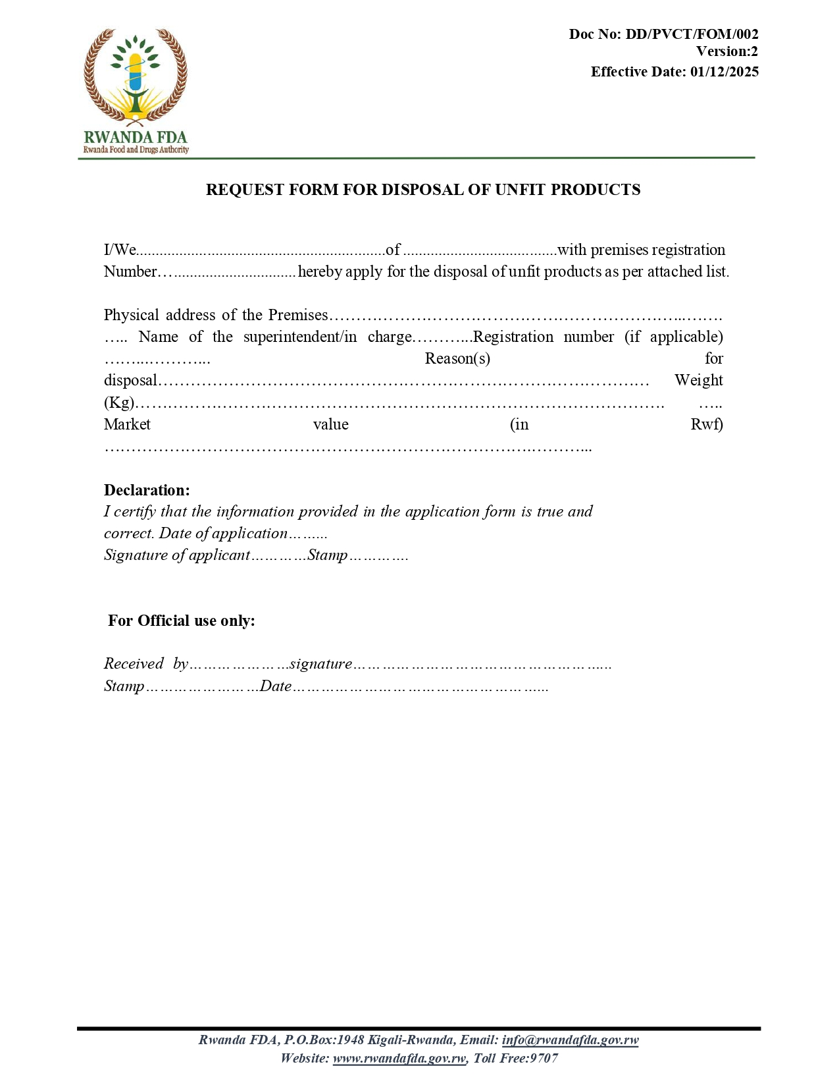

- VERIFICATION FORM FOR A REQUEST FOR DISPOSAL OF SUBSTANDARD AND FALSIFIED PRODUCTS
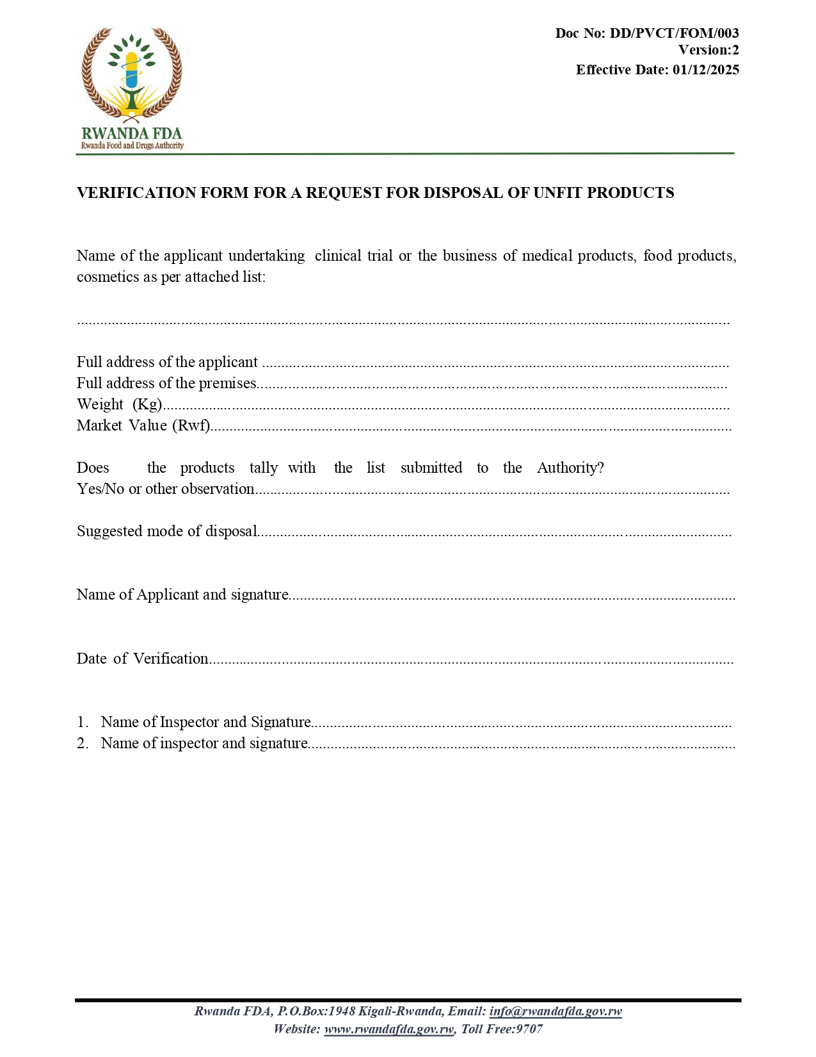
- REGISTER FORM FOR SUBSTANDARD AND FALSIFIED PHARMACEUTICAL PRODUCTS
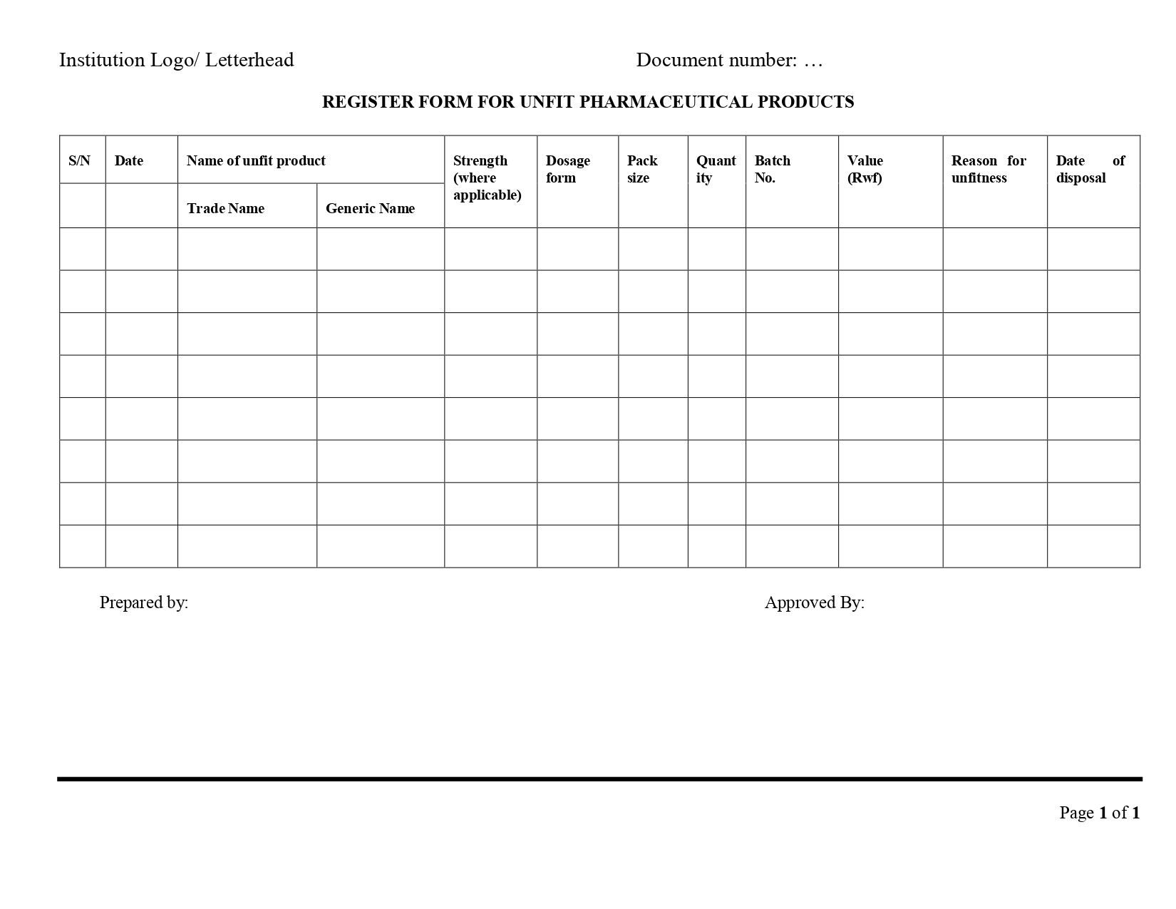

- ADVERSE DRUG EVENT REPORTING FORM

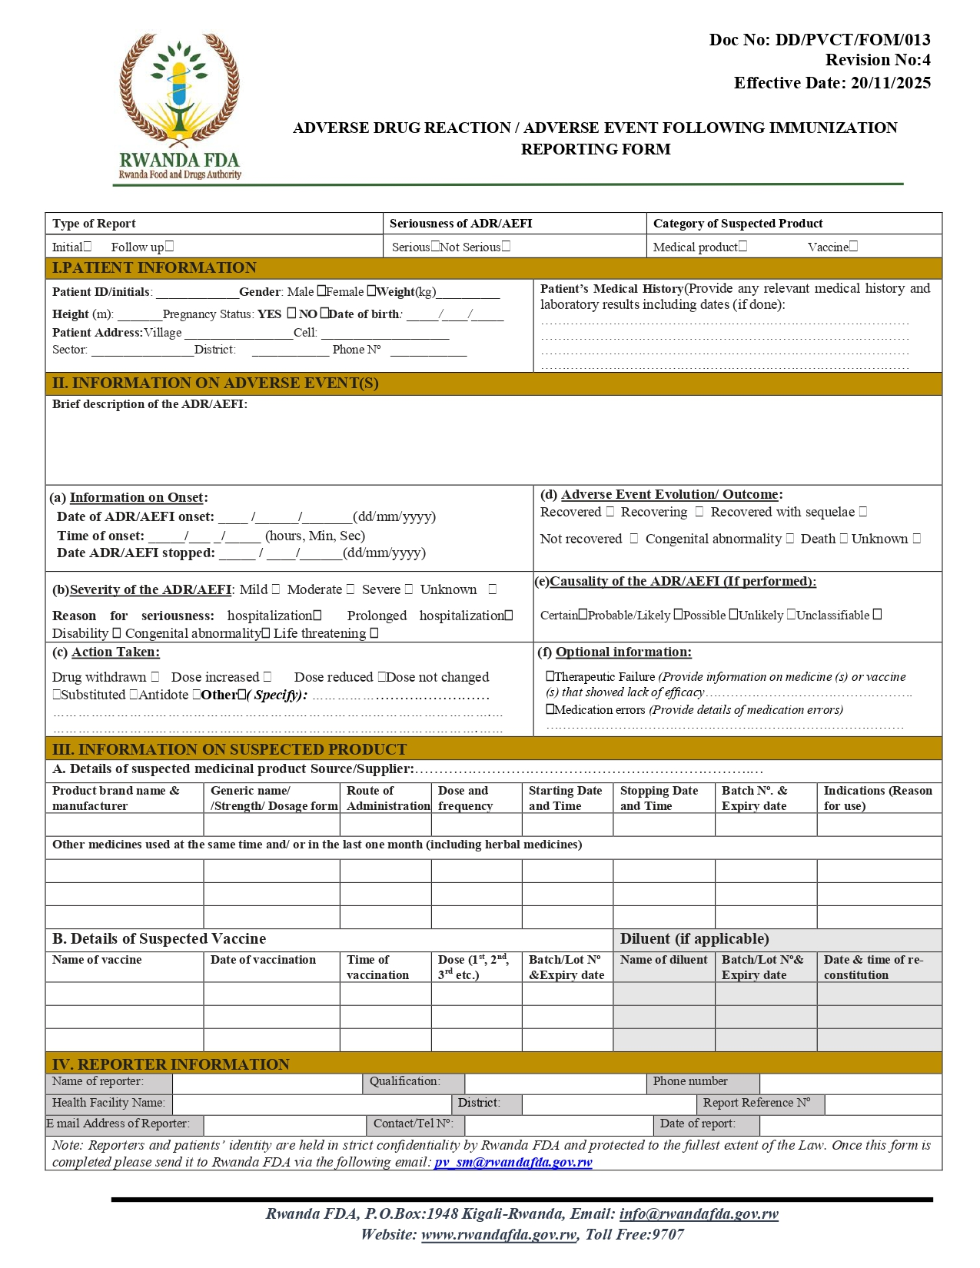
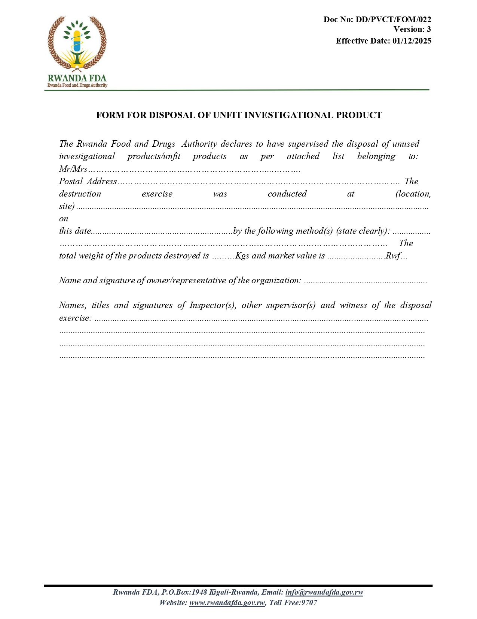

- FORM FOR DISPOSAL OF UNFIT INVESTIGATIONAL PRODUCT

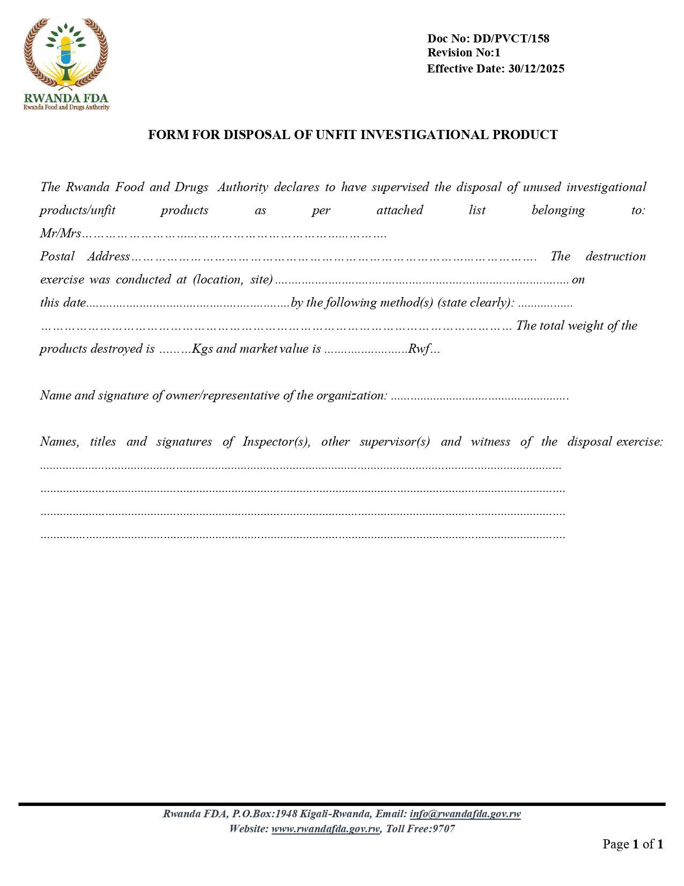

- REGISTER FOR DISPOSAL OF UNFIT INVESTIGATIONAL PRODUCT
